Snowflake Data Engineering Assignment Kyle Drewes
Task 1 — Environment Setup
Create:
• One database
• One raw schema
• One clean schema
• One X-Small warehouse
Questions
- Why is a warehouse required?
- Why do we separate raw and clean data?

-- Task 1: Setup environment

CREATE DATABASE IF NOT EXISTS Food_Truck_DB;

CREATE SCHEMA IF NOT EXISTS Food_Truck_DB.RAW;

CREATE SCHEMA IF NOT EXISTS Food_Truck_DB.CLEAN;

CREATE WAREHOUSE IF NOT EXISTS Food_Truck_WH
WAREHOUSE_SIZE = 'XSMALL'
AUTO_SUSPEND = 60
AUTO_RESUME = TRUE
INITIALLY_SUSPENDED = TRUE;

USE WAREHOUSE TASTYBYTES_WH;
USE DATABASE TASTYBYTES_DB;
USE SCHEMA RAW;

Questions
- Why is a warehouse required?
A snowflake warehouse is required because provides Snowflake with the necessary processing power such as CPU and RAM Snowflake needs to run queries and load data.
- Why do we separate raw and clean data?
Raw data keeps the original data while clean data holds a refined and filtered version of the raw data used for reporting. In addition, raw data may contain errors and inconsistencies while clean data eliminates those errors.

Task 2 — Source File Exploration
Use:
S3://sfquickstarts/tastybytes/raw_pos/menu/Identify the menu file available in this folder.
Find:
• File name
• File type
• Delimiter
• Whether a header exists
• Number of columns

CREATE OR REPLACE STAGE Food_Truck_DB.RAW.MENU_EXPLORE_STAGE
URL = 's3://sfquickstarts/tastybytes/raw_pos/menu/';
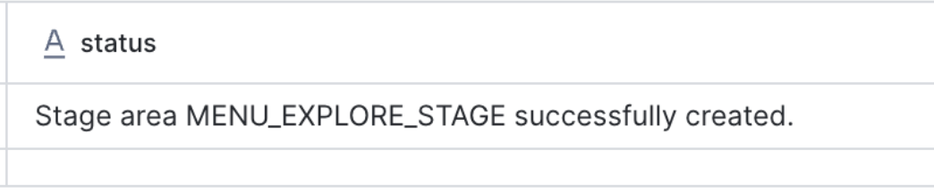
LIST @Food_Truck_DB.RAW.MENU_EXPLORE_STAGE;
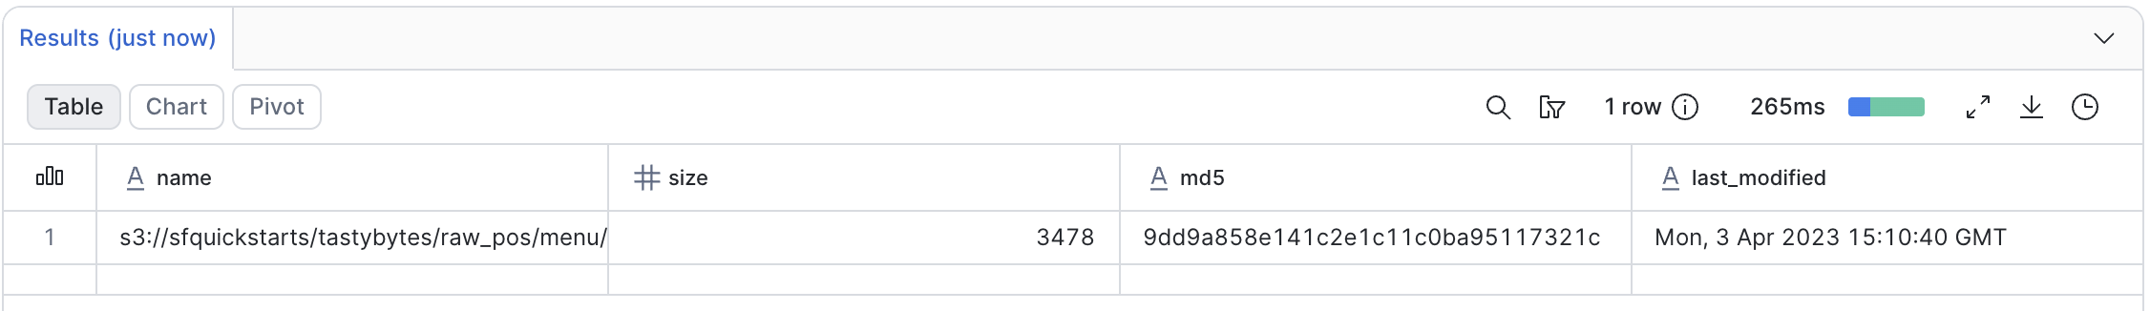

SELECT
METADATA$FILENAME AS file_name,
$1, $2, $3, $4, $5, $6, $7, $8, $9, $10, $11
FROM @Food_Truck_DB.RAW.MENU_EXPLORE_STAGE
LIMIT 5;
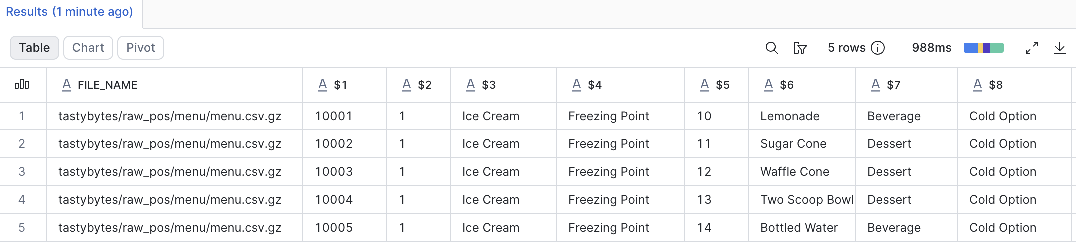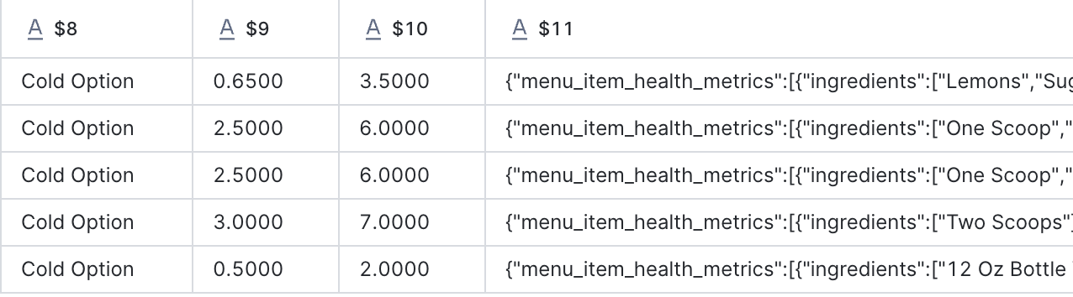

File Name: menu.csv.gz
File type: CSV
Delimiter: comma
Whether a header exists: Yes
Number of columns: 11

3)

Task 3 — File Format
Create a suitable File Format for the source menu file.
Questions
1. What file type did you configure?
2. What delimiter did you use?
3. How did you handle the header?
4. Why is a File Format required?

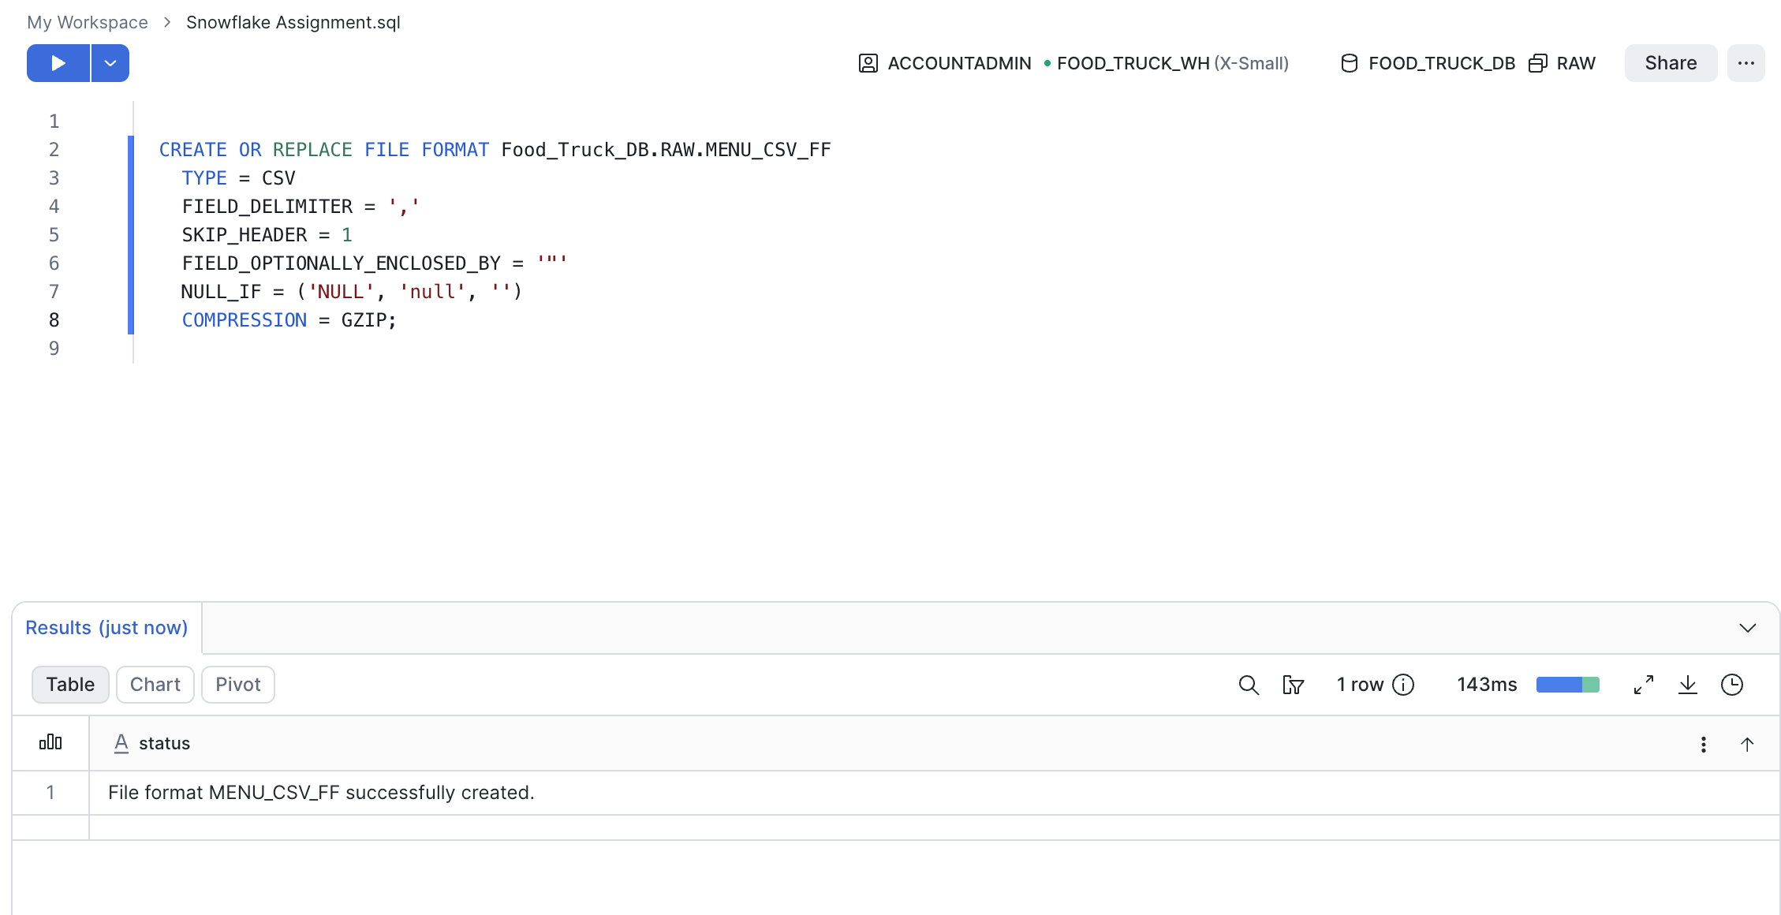
CREATE OR REPLACE FILE FORMAT Food_Truck_DB.RAW.MENU_CSV_FF
TYPE = CSV
FIELD_DELIMITER = ','
SKIP_HEADER = 1
FIELD_OPTIONALLY_ENCLOSED_BY = '"'
NULL_IF = ('NULL', 'null', '')
COMPRESSION = GZIP;

Questions:

What file type did you configure?
CSV
What delimiter did you use?
Comma

How did you handle the header?
I used the command SKIP_HEADER = 1

Why is a File Format required?

A file format indicates to Snowflake how to parse a file so the columns load correctly

4)
Task 4 — External Stage
Create an External Stage pointing to the public S3 dataset.
Create an External Stage pointing to the public S3 dataset.
Questions
1. What is the purpose of a Stage?
2. Does the Stage actually store the data inside Snowflake?

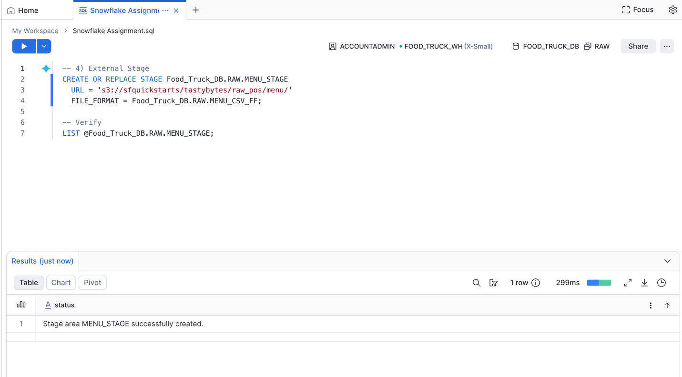

Questions

- What is the purpose of a Stage?
A stage is a location Snowfalke used to reference data files.
- Does the Stage actually store the data inside Snowflake?
No, an external stage only stores the pointer/path to S3 (setting file format). The data stays in S3 until you load it into a table

5)
Task 5 — Raw Data Loading
Create a raw menu table and load the menu file into it.
The table should include fields such as:
• Menu ID
• Truck Brand Name
• Menu Item Name
• Item Category
• Item Subcategory
• Cost Price
• Sale PriceRecord:
• Number of rows loaded
• Number of files proce

Run queries separately:

-- 5) Raw data loading
CREATE OR REPLACE TABLE Food_Truck_DB.RAW.MENU_RAW (
MENU_ID NUMBER(19,0),
MENU_TYPE_ID NUMBER(38,0),
MENU_TYPE VARCHAR,
TRUCK_BRAND_NAME VARCHAR,
MENU_ITEM_ID NUMBER(38,0),
MENU_ITEM_NAME VARCHAR,
ITEM_CATEGORY VARCHAR,
ITEM_SUBCATEGORY VARCHAR,
COST_PRICE NUMBER(38,4),
SALE_PRICE NUMBER(38,4),
MENU_ITEM_HEALTH_METRICS_OBJ VARIANT
);

-- Import from stage
COPY INTO Food_Truck_DB.RAW.MENU_RAW
FROM @Food_Truck_DB.RAW.MENU_STAGE;

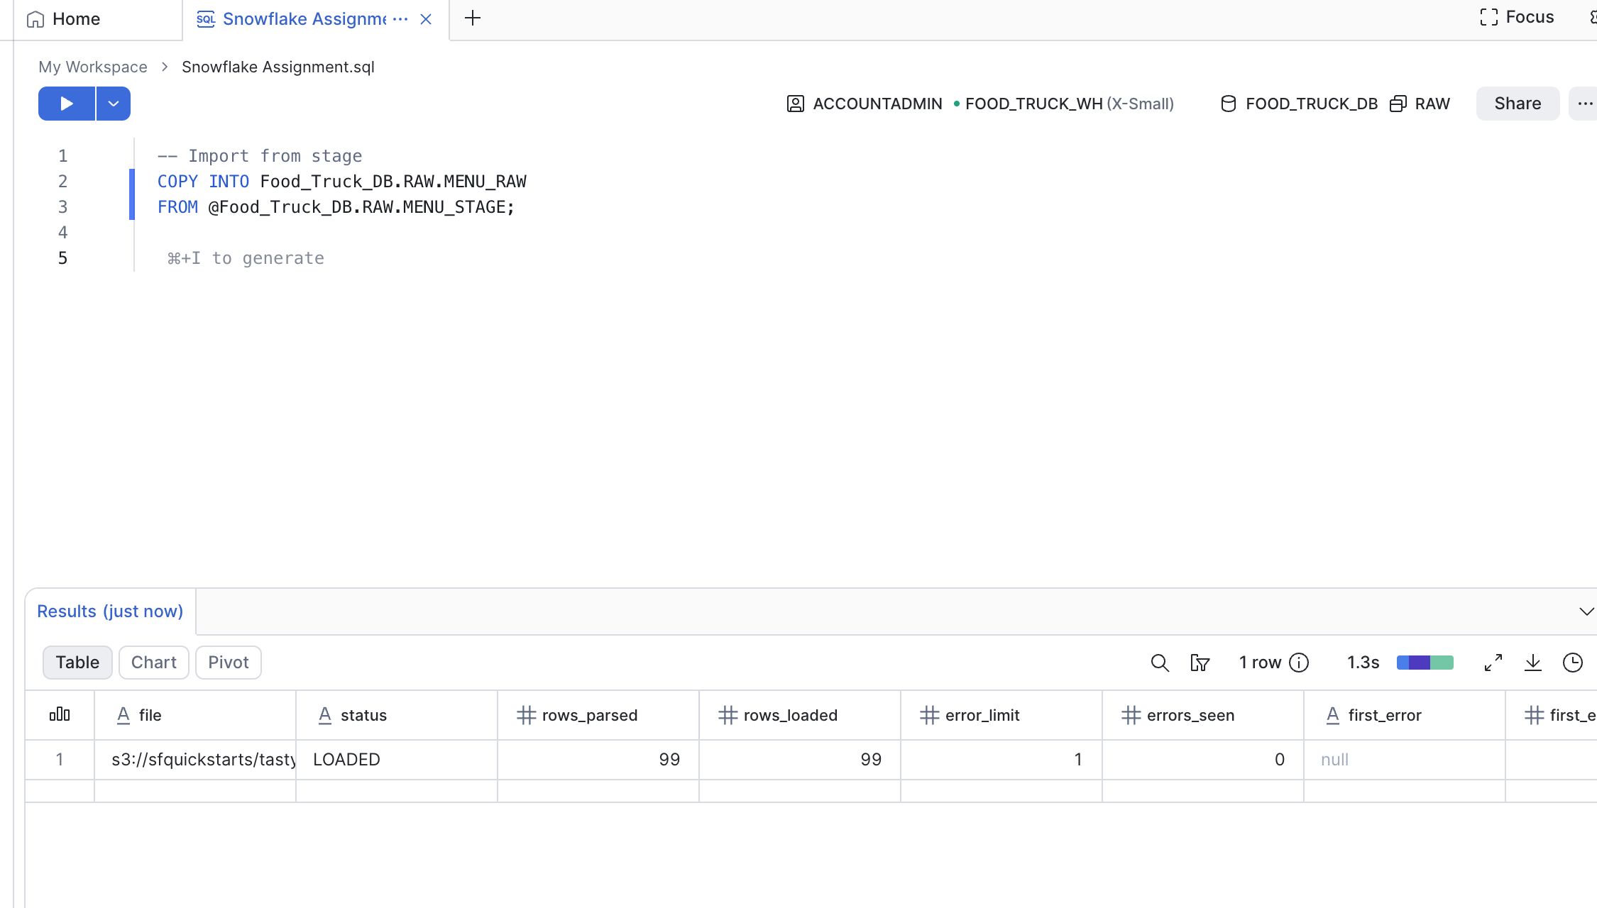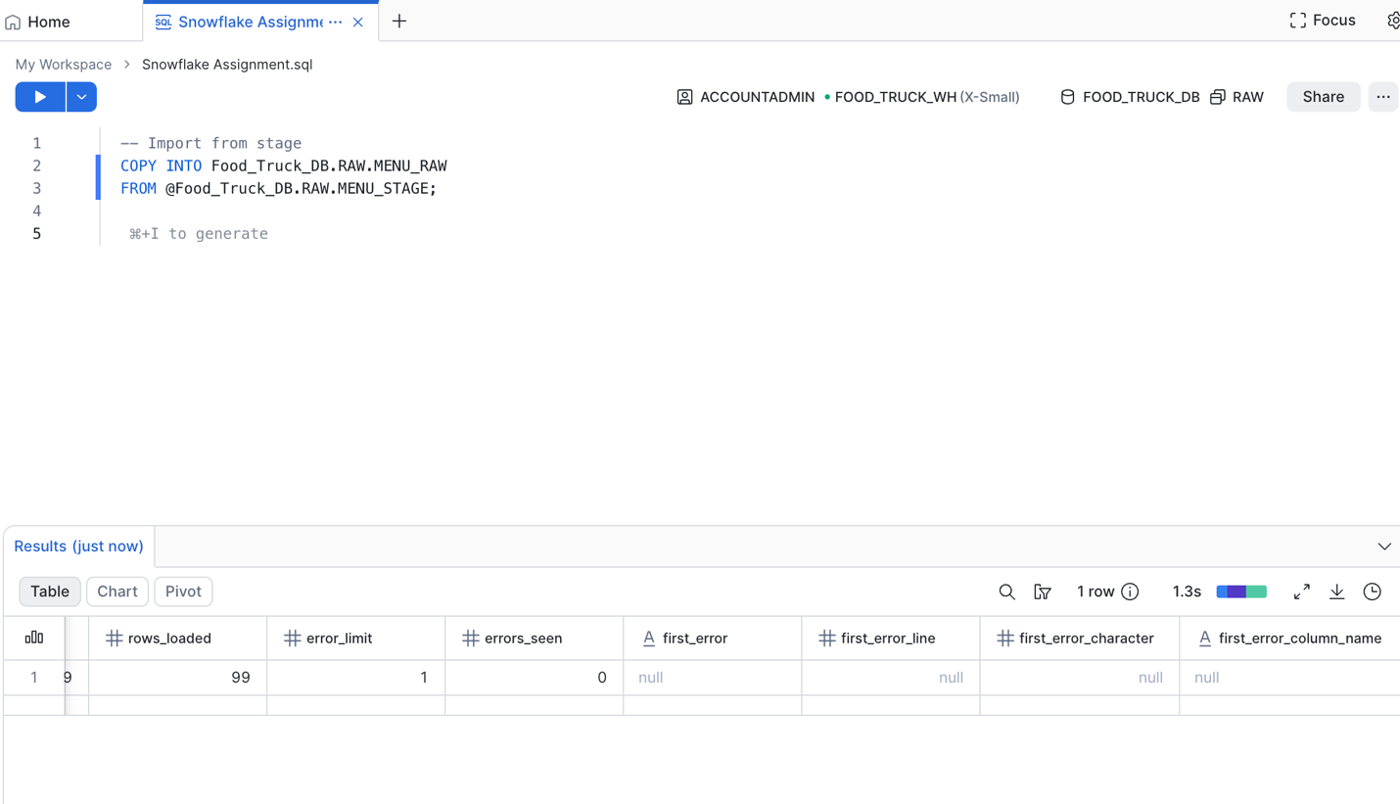

-- Check the data
SELECT * FROM Food_Truck_DB.RAW.MENU_RAW LIMIT 10;

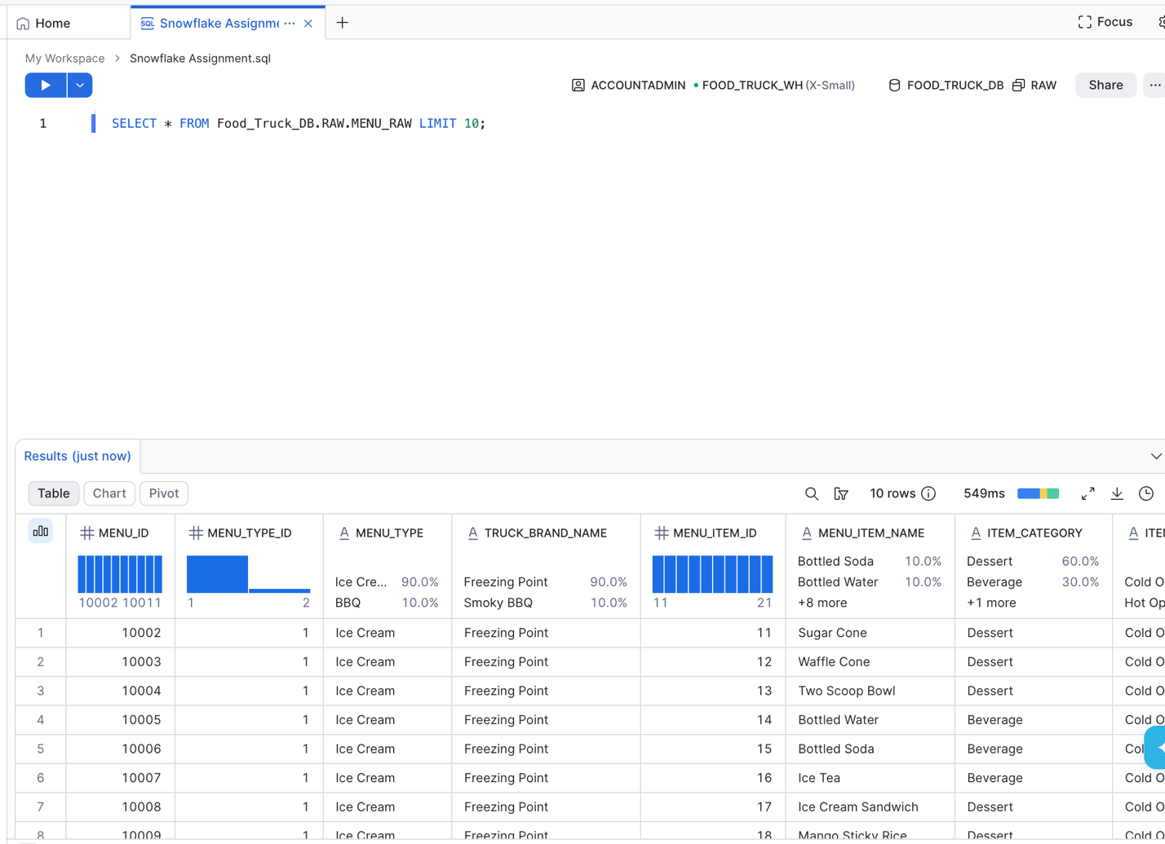

Task 6 — Data Validation
Find:
1. Total number of menu items.
2. Number of unique truck brands.
3. Number of unique categories.
4. Minimum sale price.
5. Maximum sale price.
6. Average sale price.
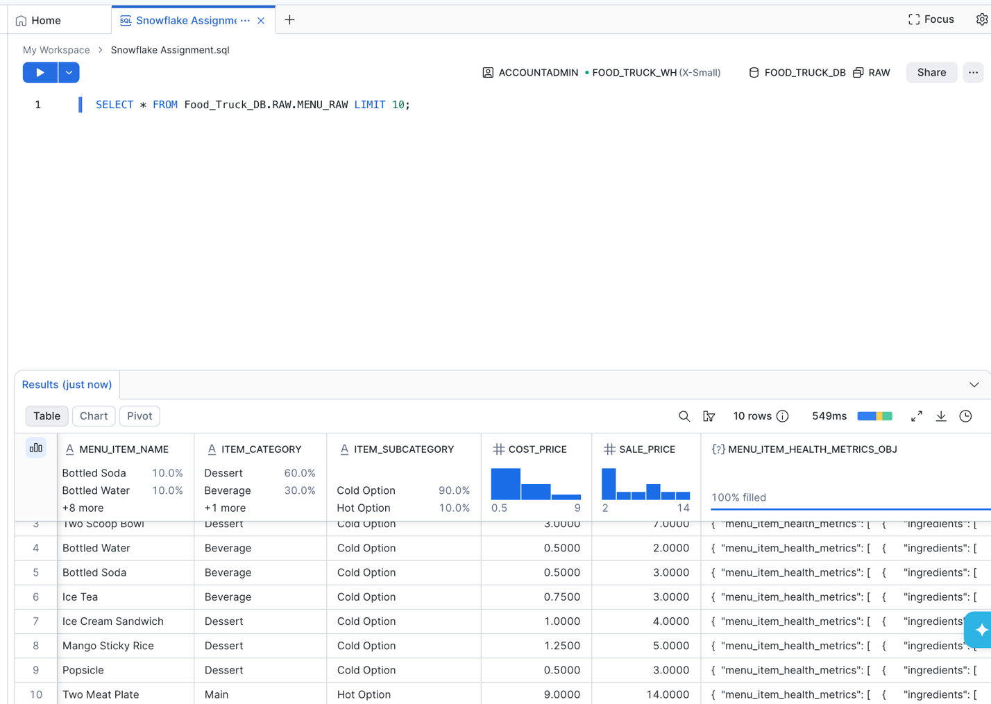

Task 6 — Data Validation
Find:
1. Total number of menu items.
2. Number of unique truck brands.
3. Number of unique categories.
4. Minimum sale price.
5. Maximum sale price.
6. Average sale price.

-- Task 6: Data Validation
SELECT
COUNT(*) AS total_menu_items,
COUNT(DISTINCT TRUCK_BRAND_NAME) AS unique_truck_brands,
COUNT(DISTINCT ITEM_CATEGORY) AS unique_categories,
MIN(SALE_PRICE) AS min_sale_price,
MAX(SALE_PRICE) AS max_sale_price,
ROUND(AVG(SALE_PRICE), 2) AS avg_sale_price
FROM Food_Truck_DB.RAW.MENU_RAW;

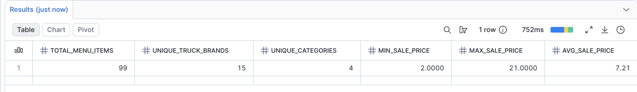

Task 7 — Transform the Data
Create a clean menu table.
Perform the following transformations:
1. Clean Menu Item Name
Remove unnecessary spaces.
2. Standardize Brand Name
Convert truck brand names to uppercase.
3. Standardize Category
Convert item categories to uppercase.
4. Calculate Profit
5. Calculate Profit Percentage
6. Create Price Category
Apply:
• Below 5 → BUDGET
• 5 to below 10 → STANDARD• 10 to below 15 → PREMIUM
• 15 and above → LUXURY
7. Create Display Name
Combine:
Truck Brand Na

-- Task 7: Transform the Data

-- 1) Clean menu table and remove unnecessary spaces
CREATE OR REPLACE TABLE Food_Truck_DB.CLEAN.MENU_CLEAN AS
SELECT
MENU_ID,
MENU_ITEM_ID,

TRIM(MENU_ITEM_NAME) AS MENU_ITEM_NAME,

-- 2) Standardize Brand Name
UPPER(TRUCK_BRAND_NAME) AS TRUCK_BRAND_NAME,

-- 3) Standardize Category
UPPER(ITEM_CATEGORY) AS ITEM_CATEGORY,

ITEM_SUBCATEGORY,
COST_PRICE,
SALE_PRICE,

-- 4) Calculate Profit
(SALE_PRICE - COST_PRICE) AS PROFIT,

-- 5) Calculate Profit Percentage
ROUND(((SALE_PRICE - COST_PRICE) / NULLIF(SALE_PRICE, 0)) * 100, 2)
AS PROFIT_PERCENTAGE,

-- 6) Create Price Category
CASE
WHEN SALE_PRICE < 5 THEN 'BUDGET' -- Below 5
WHEN SALE_PRICE >= 5 AND SALE_PRICE < 10 THEN 'STANDARD' -- 5 to below 10
WHEN SALE_PRICE >= 10 AND SALE_PRICE < 15 THEN 'PREMIUM' -- 10 to below 15
WHEN SALE_PRICE >= 15 THEN 'LUXURY' -- 15 and above
END AS PRICE_CATEGORY,

-- 7) Create Display Name
UPPER(TRUCK_BRAND_NAME) || ' - ' || TRIM(MENU_ITEM_NAME) AS DISPLAY_NAME,

-- 8) Add Load Timestamp
CURRENT_TIMESTAMP() AS LOAD_TIMESTAMP

FROM Food_Truck_DB.RAW.MENU_RAW;

Task 8 — Business Analysis
1. What are the 5 most expensive menu items?
2. What are the 5 most profitable menu items?
3. Which truck brand has the highest average selling price?
4. Which truck brand has the highest average profit?
5. How many menu items belong to each category?
6. How many items belong to each Price Category?

-- 1) What are the 5 most expensive menu items?
SELECT
DISPLAY_NAME,
MENU_ITEM_NAME,
TRUCK_BRAND_NAME,
SALE_PRICE
FROM Food_Truck_DB.CLEAN.MENU_CLEAN
ORDER BY SALE_PRICE DESC
LIMIT 5

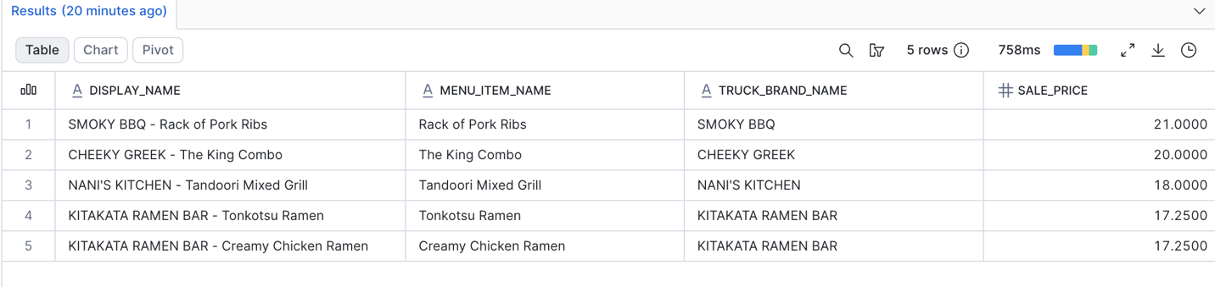

-- 2) 5 most profitable menu items
SELECT
DISPLAY_NAME,
MENU_ITEM_NAME,
TRUCK_BRAND_NAME,
PROFIT,
SALE_PRICE,
COST_PRICE
FROM Food_Truck_DB.CLEAN.MENU_CLEAN
ORDER BY PROFIT DESC
LIMIT 5;

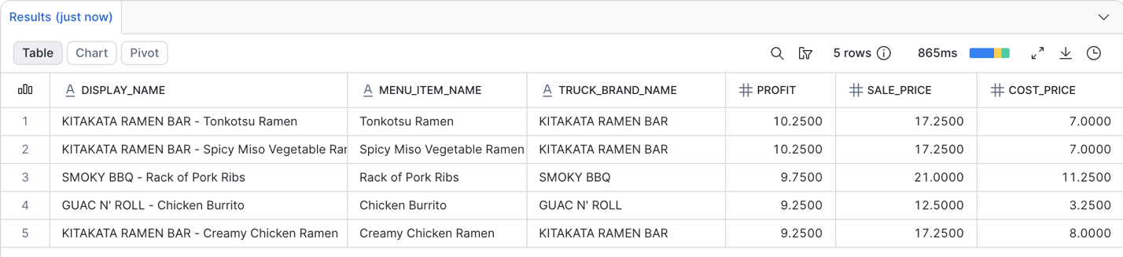

-- 3) Which truck brand has the highest average selling price
SELECT
TRUCK_BRAND_NAME,
ROUND(AVG(SALE_PRICE), 2) AS average_sale_price
FROM Food_Truck_DB.CLEAN.MENU_CLEAN
GROUP BY TRUCK_BRAND_NAME
ORDER BY average_sale_price DESC
LIMIT 1;

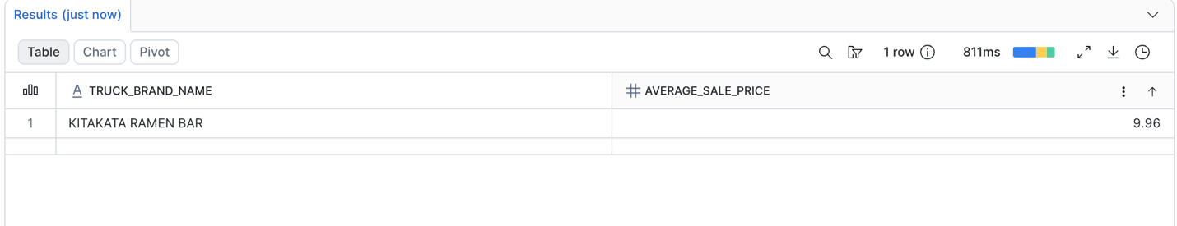
-- 4) Which truck brand has the highest average profit
SELECT
TRUCK_BRAND_NAME,
ROUND(AVG(PROFIT), 2) AS avg_profit
FROM Food_Truck_DB.CLEAN.MENU_CLEAN
GROUP BY TRUCK_BRAND_NAME
ORDER BY avg_profit DESC
LIMIT 1;

-- 5) How many menu items belong to each category?
SELECT
ITEM_CATEGORY,
COUNT(*) AS item_count
FROM Food_Truck_DB.CLEAN.MENU_CLEAN
GROUP BY ITEM_CATEGORY
ORDER BY item_count DESC;

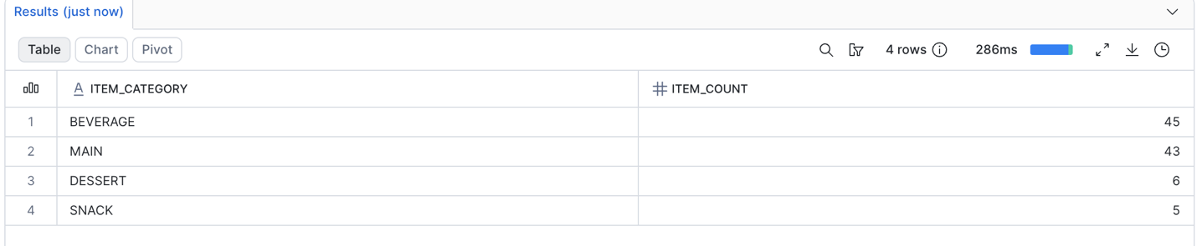

-- 6) How many items belong to each Price Category?
SELECT
PRICE_CATEGORY,
COUNT(*) AS item_count
FROM Food_Truck_DB.CLEAN.MENU_CLEAN
GROUP BY PRICE_CATEGORY
ORDER BY item_count DESC;

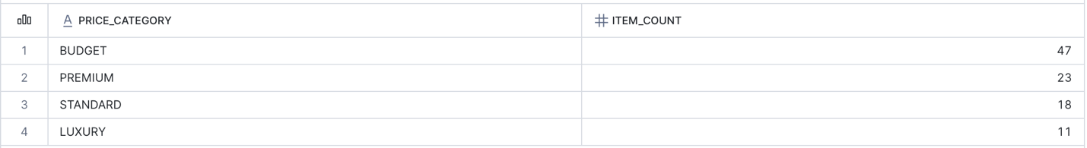

Task 9 — Data Quality
Find the number of records with:
• Missing Menu Item Name
• Missing Category
• Missing Cost Price
• Missing Sale Price
Create a simple quality status:
• All important values available → GOOD
• One value missing → REVIEW
• Multiple values missing → POOR

-- 1) Find the following records: missing menu item name, missing category, missing cost price and missing sales price
SELECT
SUM(CASE WHEN MENU_ITEM_NAME IS NULL OR MENU_ITEM_NAME = '' THEN 1 ELSE 0 END) AS missing_name,
SUM(CASE WHEN ITEM_CATEGORY IS NULL OR ITEM_CATEGORY = '' THEN 1 ELSE 0 END) AS missing_category,
SUM(CASE WHEN COST_PRICE IS NULL THEN 1 ELSE 0 END) AS missing_cost,
SUM(CASE WHEN SALE_PRICE IS NULL THEN 1 ELSE 0 END) AS missing_sale
FROM Food_Truck_DB.CLEAN.MENU_CLEAN;

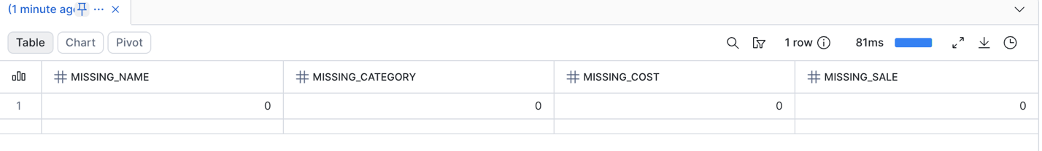

-- 2) Find the following records: Important values available, one value missing, multiple values missing
SELECT
MENU_ID,
MENU_ITEM_NAME,
ITEM_CATEGORY,
COST_PRICE,
SALE_PRICE,
CASE
WHEN MENU_ITEM_NAME IS NOT NULL
AND MENU_ITEM_NAME <> ''
AND ITEM_CATEGORY IS NOT NULL
AND ITEM_CATEGORY <> ''
AND COST_PRICE IS NOT NULL
AND SALE_PRICE IS NOT NULL
THEN 'GOOD'
WHEN (CASE WHEN MENU_ITEM_NAME IS NULL OR MENU_ITEM_NAME = '' THEN 1 ELSE 0 END)
+ (CASE WHEN ITEM_CATEGORY IS NULL OR ITEM_CATEGORY = '' THEN 1 ELSE 0 END)
+ (CASE WHEN COST_PRICE IS NULL THEN 1 ELSE 0 END)
+ (CASE WHEN SALE_PRICE IS NULL THEN 1 ELSE 0 END) = 1
THEN 'REVIEW'
ELSE 'POOR'
END AS QUALITY_STATUS
FROM Food_Truck_DB.CLEAN.MENU_CLEAN;

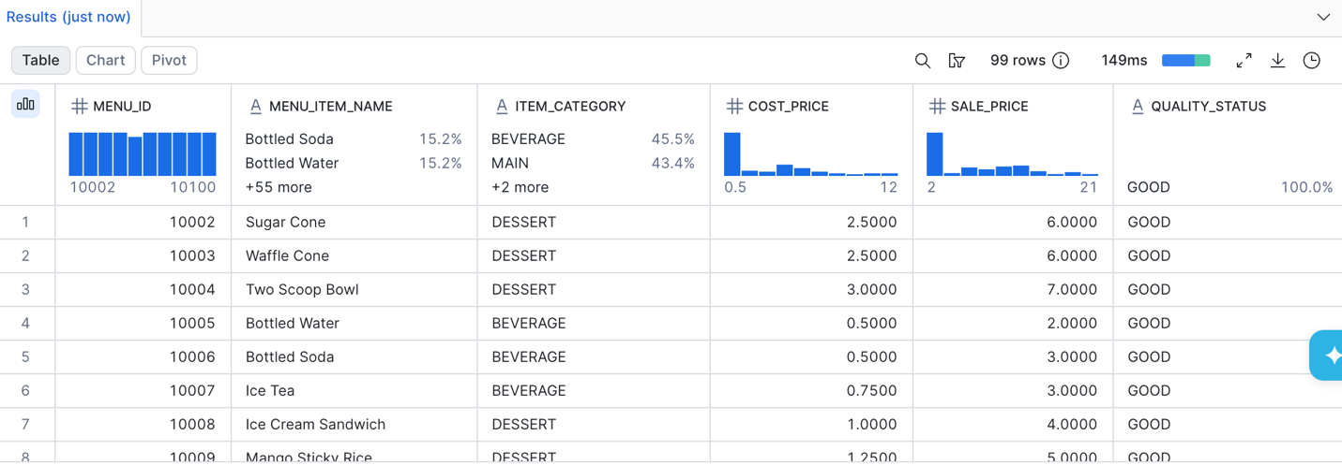

Task 10 — Final Summary
Create a truck-brand-level summary containing:
• Truck Brand Name• Total Menu Items
• Average Sale Price
• Average Profit
• Minimum Sale Price
• Maximum Sale Price
Identify the most profitable truck brand.

-- Task 10: Truck brand summary- Truck brand name, average sales price, average profit, minimum sales price and maximum sales price
SELECT
TRUCK_BRAND_NAME,
COUNT(*) AS total_menu_items,
ROUND(AVG(SALE_PRICE), 2) AS average_sale_price,
ROUND(AVG(PROFIT), 2) AS average_profit,
MIN(SALE_PRICE) AS minimum_sale_price,
MAX(SALE_PRICE) AS maximum_sale_price
FROM Food_Truck_DB.CLEAN.MENU_CLEAN
GROUP BY TRUCK_BRAND_NAME
ORDER BY average_profit DESC;

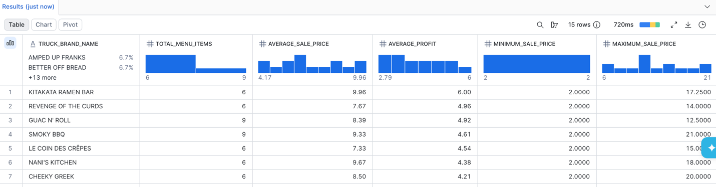

-- Most profitable truck brand
SELECT
TRUCK_BRAND_NAME AS most_profitable_brand,
ROUND(AVG(PROFIT), 2) AS average_profit
FROM Food_Truck_DB.CLEAN.MENU_CLEAN
GROUP BY TRUCK_BRAND_NAME
ORDER BY average_profit DESC
LIMIT 1;

